**ASSIGNMENT – II**

**ALARM SOUND WHEN THE TEMPERATURE IS HIGH**

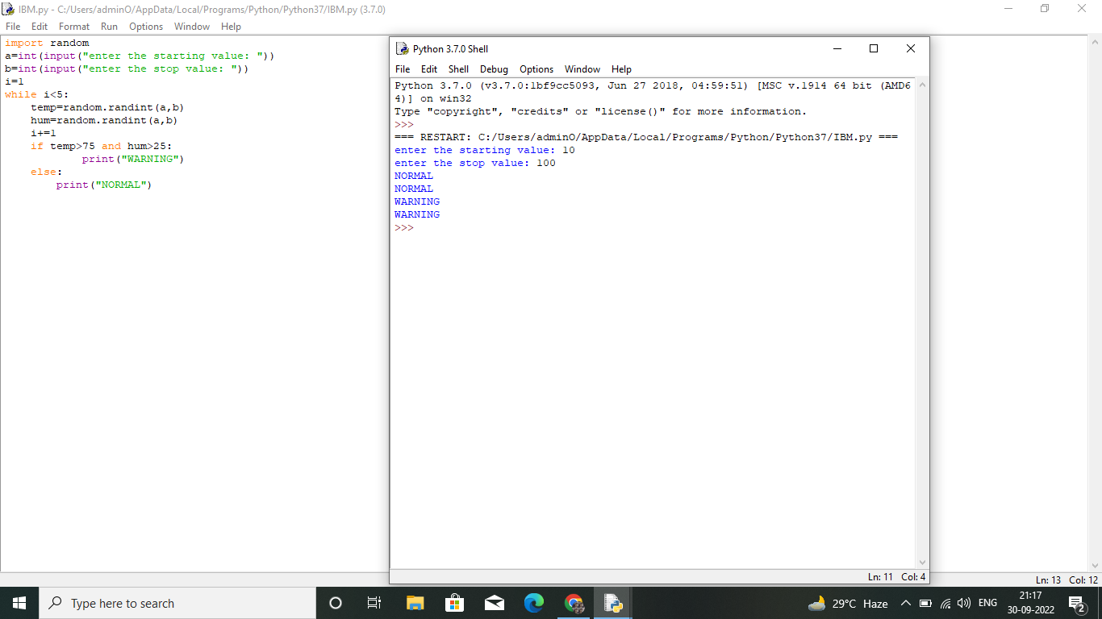

**CODE:**

import random

a=int(input("enter the starting value: "))

b=int(input("enter the stop value: "))

i=1

while i<5:

temp=random.randint(a,b)

hum=random.randint(a,b)

i+=1

if temp>75 and hum>25:

print("WARNING")

else:

print("NORMAL")

